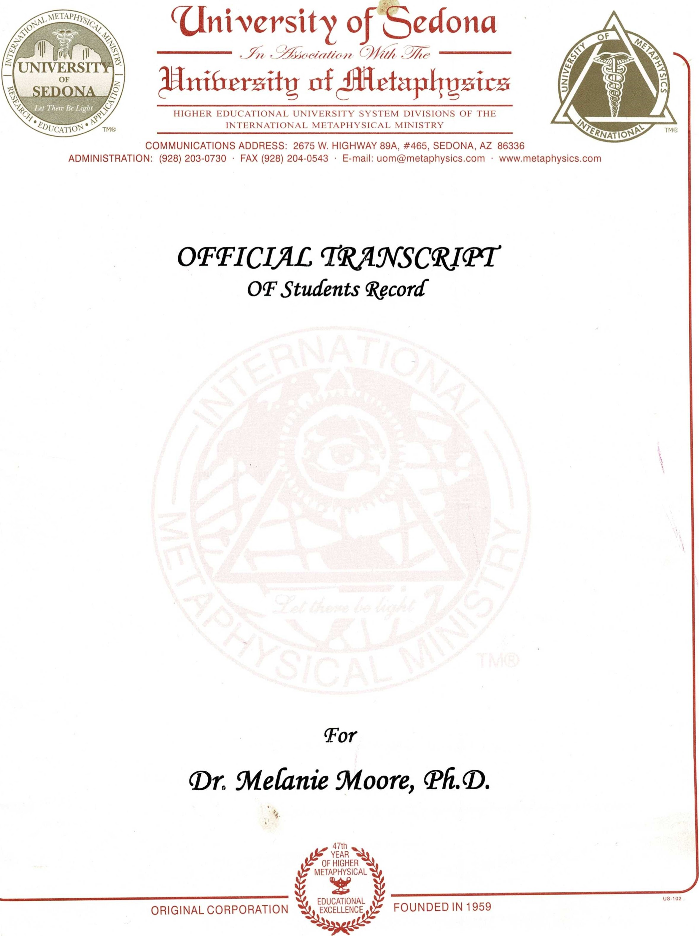
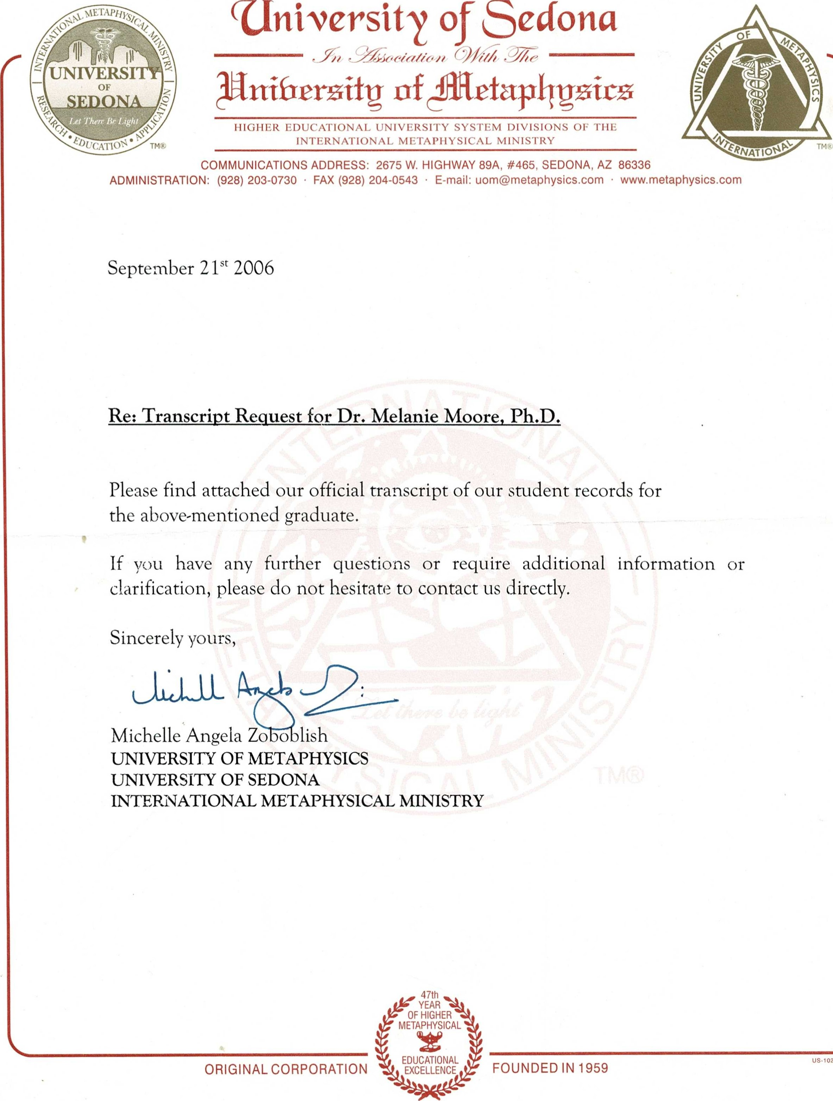
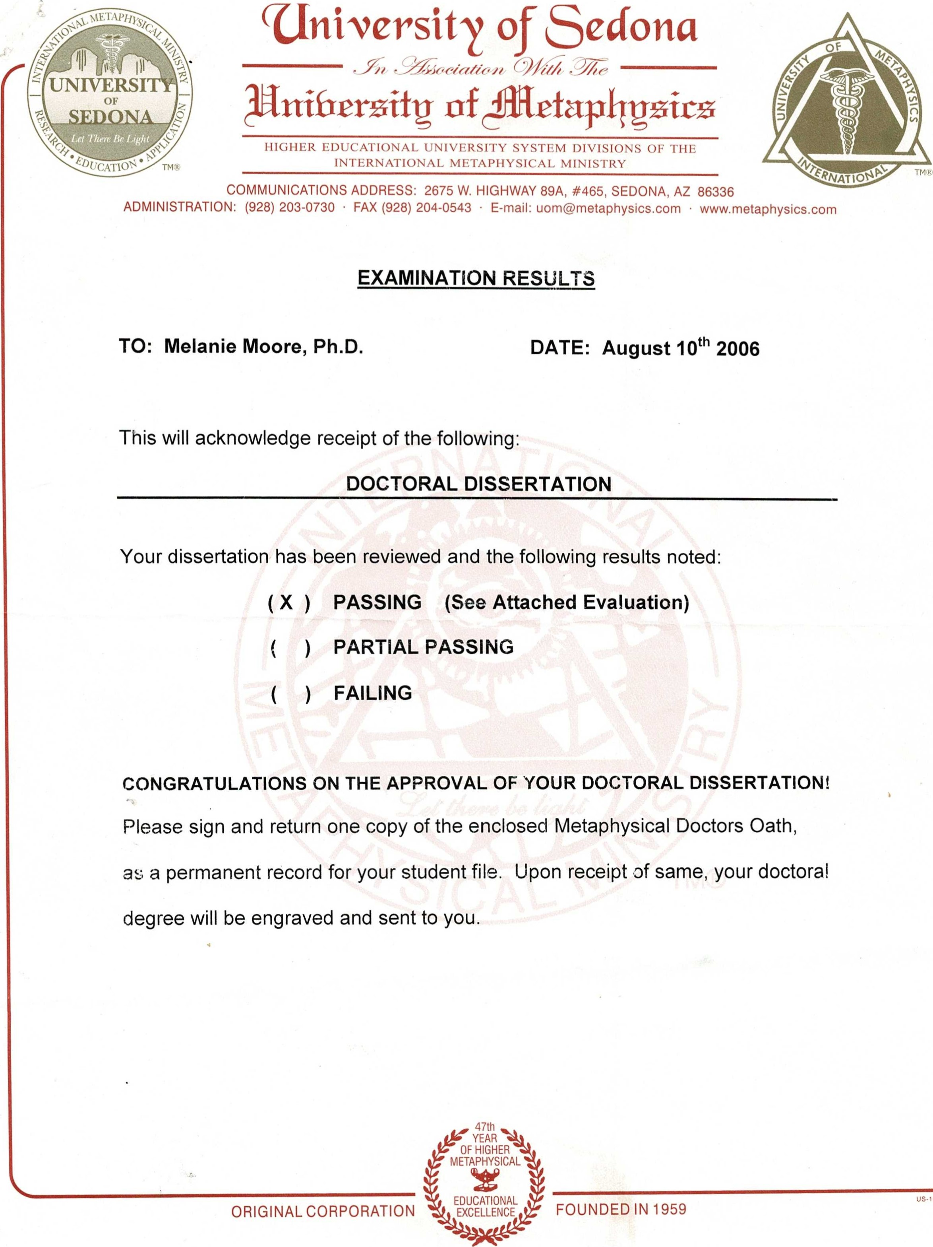
102


Uni•oersiti'
73
Let.Them HIGHER EDUCATIONAL UNIVERSITY
INTERNATIONAL MINISTRY
COMMUNICATIONS ADDRESS: 2675 W. HIGHWAY #465,
ADMINISTRATION: (928) 203-0730 FAX (928) 204-0543 E-mail: uom@metaphysics.com www.metaphysics.com
August 10th 2006
Dear: Dr. Melanie Moore, Ph.D.
Congratulations! Your OUTSTANDING dissertation in Metaphysical Parapsychology titled ''A Formula for Conscious Alchen$' has been reviewed and found to be acceptable.
This effort has been your final step in meeting the doctoral requirements of the University of Sedona. We share your extreme pride in this achievement. You will soon be receiving your doctoral degree to proudly display for the rest of your life.
Please ensure that you sign and return your Metaphysical Doctors Oath. Please print your name under your signature exactly as you wish it to be engraved on your diploma. Should you wish more then one copy of your degree, please include an additional $15.00 per copy to cover the engraving and handling charges. Please also allow approximately four to six weeks for the processing, engraving and delivering of your final degree.
Please let us know of any change of address so we can keep your student file up-to-date.
This is necessary for your continued ministerial status within the International Metaphysical Ministry. If relevant, please be aware that the awarding of any final degree is subject to the payment of all outstanding tuition, as well as the yearly Ministers Affiliation Fee.
You are also eligible to join the University's Alumni Association (which helps fund scholarships) and to have your information listed on the American Metaphysical Doctors Association Directory and the Professional Metaphysical Directory on our web site www.metaphysics.com. We have enclosed the relevant forms for your information.
We hope that you have enjoyed your Doctoral.program and that you will recommend the University of Metaphysics/Sedona to others. It was our sincere pleasure to have been of service to you. Please do not hesitate to contact us should you require any future assistance. Again, congratulations on this wonderful accomplishment and best wishes for all your future endeavors.
us-102
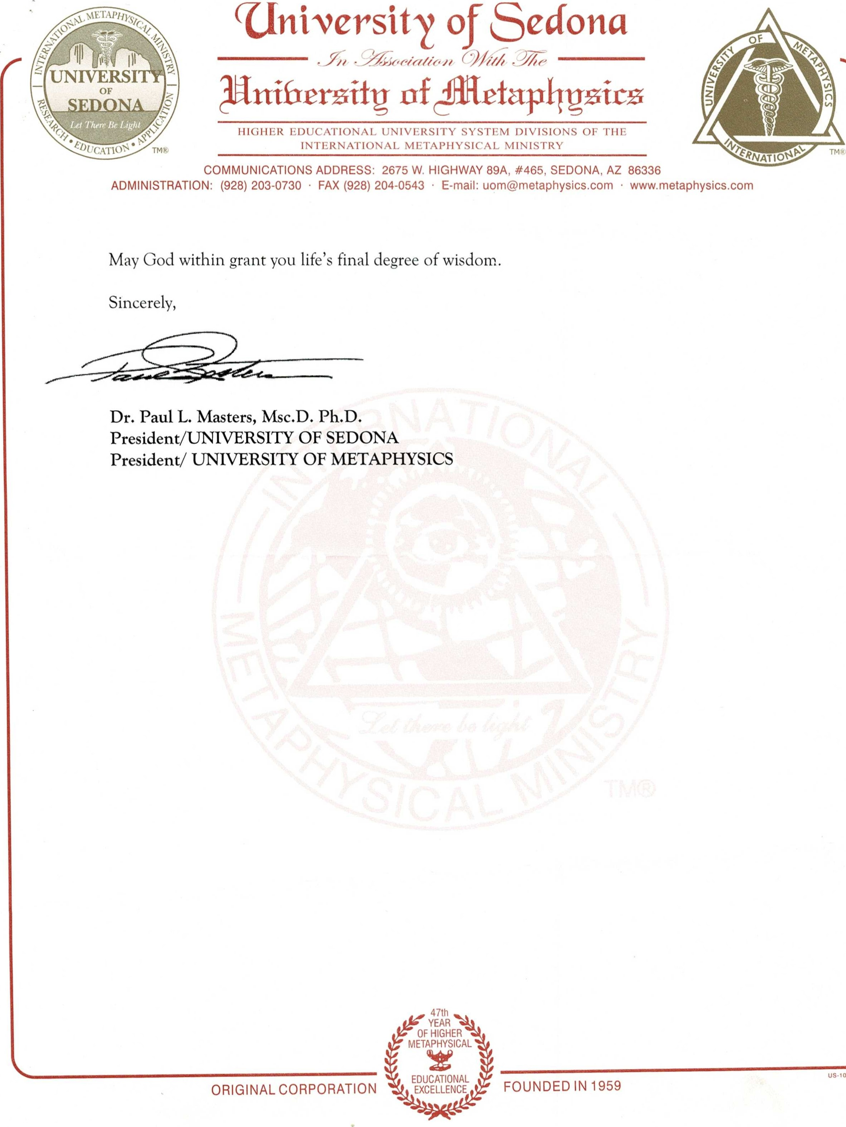
02
Department of Graduate Studies

CERTIFICATE OF APPROVAL

Ph.D. DISSERTATION
This is to certify that the Ph.D. dissertation of

Melanie Moore
has been approved by the Examining Committee for the dissertation requirements for the Ph.D. in Metaphysical Parapsychology degree of the University of Sedona.
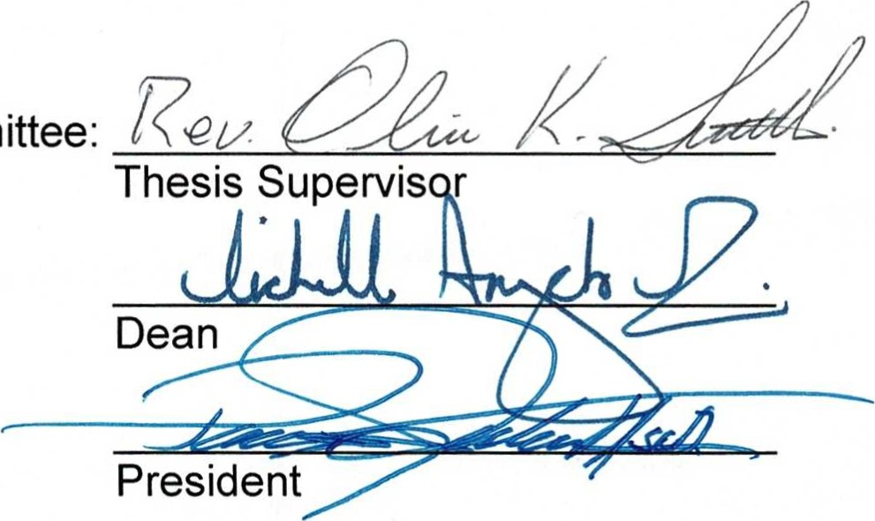
Dissertation
Committee:

DISSERTATION EVALUATION REPORT
Name: Melanie Moore Date: 7/18/06
Degree: Ph. D in Metaphysical Parapsychology
Title: The Formula for Conscious Alchemy
Comments on the Introduction: This introduction is an excellent encapsulation of the central theme of the thesis. You have immediately eased the readers into essence of your research with this definition: "This formula is the new modern day scripture, the divine revelation channeled and developed through my studies of people and their relationships, lifestyle, reality creation, and energy manipulation."
Comments on Review of Literature: Much of your information and certainly your enthusiasm is derived from the work of an excellent selection of authors. From Tolle you extract this important thought: "The word enlightenment conjures up the idea of some superhuman accomplishment, and the ego likes to keep it that way, but it is simply your natural state of felt oneness with Being. It is a state of connectedness with something immeasurable and indestructible, something that, almost paradoxically, is essentially you and yet is much greater than you."
Comments on Findings: Special note is give to your statements on Freedom and No Limitations. You write, "Apart from the constraints of our actual physical bodies we have no limits to our possible achievements. Our wildest dreams and fantasies can be made our every day reality and life by practicing self belief and going beyond any egoic limitations and excuses we give ourselves, and far worse accept from other people. On reclaiming and owning our individual personal power can we can start creating our happiness and life in alignment with whom and what we really are. When we can find our loving pleasure
zone which emits the feeling ofjoy, so creating positive excited emotion, we can be absolutely assured that these feelings come from our soul connection and means we are on the correct soul path." The strength of your work is found in the fundamentals expressed in this and similar statements of the fundamentals."
Comments on Discussion: A very interesting thought: "We can use this formula backwards to show what original negative thought patterning a negative life condition springs from. So the conditionings and thoughts we are having which are not conducive towards what we would really like to create, and thus actually bringing back into our lives the opposite to what we really would like."
Comments on Summary and Conclusions: You present a critical analysis of your subject, and a special note is given to these words in conclusion. "It is time for us all to start taking responsibility for the thoughts we generate and the dramas we create that contribute to the mass reality of the human consciousness."
Overall Comments: Extensive research and study are evident in this well—written and comprehensive thesis submission. You have successfully achieved your stated goal with a fine presentation of the findings of your position. Good work!

NAME: Dr. Melanie Moore, Ph.D. DATE OF ENTRANCE: April 28th 2006
ADDRESS: 4 Sedemuda Road GRADING SYSTEM: Pass/Fail
CITY & STATE: Sidmouth, Devon, EXIO 9YA U.K. DATE OF GRADUATION: August 10th 2006
REMARKS: Diligent Student DEGREES: Bachelors and Masters in Metaphysical Science
Ph.D. in Metaphysical Parapsychology
SUBJECT | PIF CRD |  | SUBJECT | PIF CRD
MINISTERS COURSE STUDY LESSONS  -ATTRACTING & MAINTAINING PROSPERITY  -CONSCIOUS SPIRITUAL SELF-REALIZATION  FOR SUCCESS  -HOW TO PUT ACTION IN YOUR MEDITATION FOR SUCCESS & HAPPINESS  -MASTERING YOUR WEAKNESSES THROUGH  -ESTABLISHING & MAINTAINING A POSITIVE TRANSCENDENT ATTITUDE  -METAPHYSICAL PRINCIPLES OF WINNING THE GAME OF LIFE  -ESTABLISHING MYSTICAL SELF-DIRECTION  -SPIRITUAL MIND MAGNETISM  -CHANNELING GOD-POWER INTO YOUR  DAILY ACTIVITIES  -ELIMINATING THE NEGATIVE AND  STRENGTHENING THE POSITIVE  -SPIRITUAL MIND TREATMENT  -HOW TO HANDLE PROBLEMS AS THEY ARISE  -ESTABLISHING POSITIVE NEW PATTERNS  IN YOUR LIFE  -ACTIVITY VISUALIZATION  -PSYCHIC MECHANICS OF SUCCESS  -THE POWER OF MEDITATION PRACTICES | p  p  p  p  P  P  p p  p  p  p  p  p  p p | 2.5  2.5  2.5  2.5  2.5  2.5  2.5  2.5  2.5  2.5  2.5  2.5  2.5  2.5  2.5  2.5 | -CHANGING NEGATIVE TRENDS TO  POSITIVE ONES  -COMPLETE DAILY MENTAL REBIRTHING TREATMENT  -METAPHYSICAL LAWS OF SUCCESS  -HOW TO GIVE METAPHYSICAL TREATMENTS  -HOW TO USE INTUITIVE ESP FOR  SUCCESS & HAPPINESS  -THE ROLE OF DIET & SEX IN METAPHYSICS  -METAPHYSICAL PHILOSOPHY OF NEW  CONSCIOUSNESS FOR SUCCESSFUL LIVING  -TRANSFORMATION  -HOW TO HAVE ALL CHANNELS OPEN FOR SUCCESS  -UNDERSTANDING & USING COSMIC MIND TELEPATHY FOR SUCCESS AND HAPPINESS  -HOW TO PRACTICE THE POWER OF TRANSCENDENT AWARENESS IN DAILY LIVING  -METAPHYSICAL SENSITIVITY TRAINING  -CONVINCING YOURSELF - YOU CAN  -REACTION CONTROL - HOW TO HAVE POSITIVE CONTROL OVER YOUR LIFE | p  p p p  p  p  p  p p  p  p p  p p | 2.5  2.5  2.5  2.5  2.5  2.5  2.5  2.5  2.5  2.5  2.5  2.5  2.5  2.5

P = F=FAIL CRD
1

NAME: Dr. Melanie Moore, Ph.D.
SUBJECT | PIF CRD |  | SUBJECT PIF CRD
MINISTERS COURSE STUDY LESSONS  (Continued)  -MOTIVATION  -POSITIVE CONDITIONED REFLEX LIVING  -METAPHYSICAL PRINCIPLES OF OVERCOMING  -METAPHYSICAL PRINCIPLES OF MATERIALIZING  -METAPHYSICAL PRINCIPLES FOR  ACHIEVING HAPPINESS  -HOW TO LIVE THE METAPHYSICAL LIFE DAILY  -METAPHYSICAL PRINCIPLES OF  PROSPERITY  -PROJECTING THE REAL YOU TO OTHERS  -CONTROLLING PSYCHIC VIBRATIONS IN YOUR IMMEDIATE ENVIRONMENT  -ESTABLISHING AND MAINTAINING CONTROL  OVER YOUR LIFE  -MODERATION  -CREATIVE THINKING - OR FINDING THE  INTUITIVE IDEAS THAT CAN BRING SUCCESS  -CREATING A NEW SELF-IMAGE FOR  SUCCESSFUL LIVING  -METAPHYSICAL PRINCIPLES OF ACHIEVING SUCCESS  -METAPHYSICAL PRINCIPLES OF SELFBELIEF | p  p p  p  p  p  p  p  p  p  p  p  p  p  P | 2.5  2.5  2.5  2.5  2.5  2.5  2.5  2.5  2.5  2.5  2.5  2.5  2.5  2.5  2.5 | -PSYCHIC-MYSTICAL SECRETS OF HAVING p 2.5 PRAYER ANSWERED  -DEVELOPING A PROSPERITY MENTALITY p 2.5  -ESTABLISHING & ACCOMPLISHING YOUR p 2.5 GOALS  TOTAL 48P 120
 | p  p p  p  p  p  p  p  p  p  p  p  p  p  P |  | (X) MINISTERS AND PRACTITIONERS  CREDIT PROGRAM  July 12th 2006  MINISTERS AND PRACTITIONER DIPLOMAS AWARDED  July 12th 2006  (X) BACHELOR DEGREE CREDIT PROGRAM  July 12th 2006  BACHELOR IN METAPHYSICAL SCIENCE DEGREE AWARDED: July 12th 2006  MEDITATION DYNAMICS  (Non-Credit)  -TELEPATHIC THOUGHT CONTROL x  -MEDITATION PROGRAMMING x  -MEDITATIONAL SYNTHESIS x  -TRANSCENDENT VISUALIZATION x  MASTER IN METAPHYSICAL SCIENCE  DEGREE AWARDED: July 17th 2006  ( TOTAL CREDIT UNITS = 65 )
F -FAIL CRD -
2

NAME: Dr. Melanie Moore. Ph.D.
SUBJECT | PIF CRD |  | SUBJECT | PIF CRD
MASTER DEGREE LEVEL LESSONS  -THE METAPHYSICAL PSYCHOLOGY OF  CONSCIOUSNESS (LEVELS I - IV)  -PSYCHIC-MYSTICAL ASPECTS OF  METAPHYSICS (LEVELS I-ill)  -PASTORAL PSYCHOLOGY: ITS PRACTICE IN METAPHYSICS  -DREAM INTERPRETATION: ITS ROLE IN METAPHYSICS  -PRACTITIONER'S METAPHYSICAL HEALING  PRACTICE (LEVEL l)  -THE BIBLE AND METAPHYSICS  -MEDITATION AND ITS SIGNIFICANCE TO METAPHYSICAL PRACTICE  -SELF-HYPNOSIS AND ITS RELATION TO METAPHYSICAL PRACTICE  -YOGA: ITS ADAPTATION TO WESTERN  THINKING  -EXPLORING THE CHOICE OF METAPHYSICAL  OPERATION: TEACHING AND/OR  COUNSELING CENTER OR CHURCH  -PROFESSIONALISM: YOUR DOCTORAL  IMAGE AND DEALING WITH THE PUBLIC  TOTAL CREDIT UNITS-COURSES | P  p  p  p  p p p  p  p  p  p  12 P | 10.0  7.5  5.0  2.5  2.5  2.5  2.5  2.5  2.5  2.5  2.5  45 | MASTER THESIS TITLE p 20  Psychic Protection Techniques and Personal  Empowerment Procedures Integrated into the Education and Mental Health Systems  ph.D.  In Metaphysical Parapsychology  DEGREE AWARDED: August 10th 2006 University of Sedona  DISSERTATION TITLE P 30  The Formula for Conscious Alchemy
 | P  p  p  p  p p p  p  p  p  p  12 P | 10.0  7.5  5.0  2.5  2.5  2.5  2.5  2.5  2.5  2.5  2.5  45 | Approved by:    Dr. Paul Leon Masters, Msc.D.  Dean/UNlVERSlTY OF METAPHYSICS  INTERNATIONAL METAPHYSICAL MINISTRY  DATED: September 21 ^{st} 2006
DATE COMPLETED: July 17th 2006
P = F = FAIL =
3

